**Van Allen Radiation Belt**

From Wikipedia, the free encyclopedia

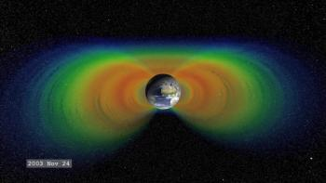

This video illustrates changes in the shape and intensity of a cross section of the Van Allen belts

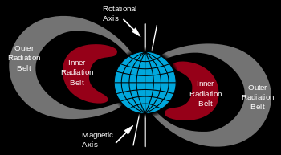

Van Allen radiation belts (cross section)

A **radiation belt** is a layer of energetic charged particles that is held in place around a magnetized planet, such as the Earth, by the planet's magnetic field. The Earth has two such belts and sometimes others may be temporarily created. The discovery of the belts is credited to James Van Allen and as a result the Earth's belts bear his name. The main belts extend from an altitude of about 1,000 to 60,000 kilometers above the surface in which region radiation levels vary. Most of the particles that form the belts are thought to come from solar wind and other particles by cosmic rays. The belts are located in the inner region of the Earth's magnetosphere. The belts contain energetic electrons that form the outer belt and a combination of protons and electrons that form the inner belt. The radiation belts additionally contain less amounts of other nuclei, such as alpha particles. The belts endanger satellites, which must protect their sensitive components with adequate shielding if their orbit spends significant time in the radiation belts. In 2013, NASA reported that the Van Allen Probes had discovered a transient, third radiation belt, which was observed for four weeks until destroyed by a powerful, interplanetary shock wave from the Sun.

**Discovery**

Kristian Birkeland, Carl Størmer, and Nicholas Christofilos had investigated the possibility of trapped charged particles before the Space Age. Explorer 1 and Explorer 3 confirmed the existence of the belt in early 1958 under James Van Allen at the University of Iowa. The trapped radiation was first mapped out by Explorer 4, Pioneer 3 and Luna 1.

The term *Van Allen belts* refers specifically to the radiation belts surrounding Earth; however, similar radiation belts have been discovered around other planets. The Sun itself does not support long-term radiation belts, as it lacks a stable, global dipole field. The Earth's atmosphere limits the belts' particles to regions above 200–1,000 km, while the belts do not extend past 7 Earth radii *RE*. The belts are confined to a volume which extends about 65° from the celestial equator.

**Research**

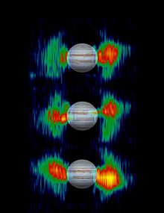

Jupiter's variable radiation belts

The NASA Van Allen Probes mission will go further and gain scientific understanding (to the point of predictability) of how populations of relativistic electrons and ions in space form or change in response to changes in solar activity and the solar wind. NASA Institute for Advanced Concepts–funded studies have proposed magnetic scoops to collect antimatter that naturally occurs in the Van Allen belts of Earth, although only about 10 micrograms of antiprotons are estimated to exist in the entire belt.

The Van Allen Probes mission successfully launched on August 30, 2012. The primary mission is scheduled to last two years with expendables expected to last four. NASA's Goddard Space Flight Center manages the overall Living With a Star program of which the Van Allen Probes is a project, along with Solar Dynamics Observatory (SDO). The Applied Physics Laboratory is responsible for the overall implementation and instrument management for the Van Allen Probes.

Radiation belts exist around other planets and moons in the solar system that have magnetic fields powerful enough to sustain them. To date most of these radiation belts have been poorly mapped. The Voyager Program (namely Voyager 2) only nominally confirmed the existence of similar belts on Uranus and Neptune.

**Outer belt**

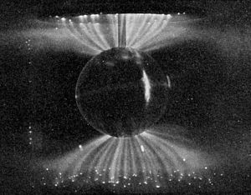

Laboratory simulation of the Van Allen belt's influence on the Solar Wind; these aurora-like Birkeland currents were created by the scientist Kristian Birkeland in his terrella, a magnetized anode globe in an evacuated chamber

The outer belt consists mainly of high energy (0.1–10 MeV) electrons trapped by the Earth's magnetosphere. It is almost toroidal in shape, extending from an altitude of about three to ten Earth radii (*RE*) or 13,000 to 60,000 kilometers (8,100 to 37,300 mi) above the Earth's surface. Its greatest intensity is usually around 4–5 *RE*. The outer electron radiation belt is mostly produced by the inward radial diffusion and local acceleration due to transfer of energy from whistler-mode plasma waves to radiation belt electrons. Radiation belt electrons are also constantly removed by collisions with atmospheric neutrals, losses to magnetopause, and the outward radial diffusion. The gyroradii for energetic protons would be large enough to bring them into contact with the Earth's atmosphere. The electrons here have a high flux and at the outer edge (close to the magnetopause), where geomagnetic field lines open into the geomagnetic "tail", fluxes of energetic electrons can drop to the low interplanetary levels within about 100 km (62 mi), a decrease by a factor of 1,000.

In 2014 it was discovered that the inner edge of the outer belt is characterized by a very sharp edge, below which highly relativistic electrons (> 5MeV) cannot penetrate. The reason for this shield-like behavior is not well understood.

The trapped particle population of the outer belt is varied, containing electrons and various ions. Most of the ions are in the form of energetic protons, but a certain percentage are alpha particles and O+ oxygen ions, similar to those in the ionosphere but much more energetic. This mixture of ions suggests that ring current particles probably come from more than one source.

The outer belt is larger than the inner belt and its particle population fluctuates widely. Energetic (radiation) particle fluxes can increase and decrease dramatically as a consequence of geomagnetic storms, which are themselves triggered by magnetic field and plasma disturbances produced by the Sun. The increases are due to storm-related injections and acceleration of particles from the tail of the magnetosphere.

On February 28, 2013, a third radiation belt, consisting of high-energy ultra relativistic charged particles, was reported to be discovered. In a news conference by NASA's Van Allen Probe team, it was stated that this third belt is generated when a mass coronal ejection is created by the Sun. It has been represented as a separate creation which splits the Outer Belt, like a knife, on its outer side, and exists separately as a storage container for a month's time, before merging once again with the Outer Belt.

The unusual stability of this third, transient belt has been explained as due to a 'trapping' by the Earth's magnetic field of ultra relativistic particles as they are lost from the second, traditional outer belt. While the outer zone, which forms and disappears over a day, is highly variable owing to interactions with the atmosphere, the ultra-relativistic particles of the third belt are thought to not scatter into the atmosphere, as they are too energetic to interact with atmospheric waves at low latitudes. This absence of scattering and the trapping allows them to persist for a long time, finally only being destroyed by an unusual event, such as the shock wave from the sun which eventually destroyed it.

**Inner belt**

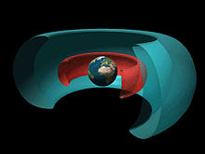

Cutaway drawing of two radiation belts around Earth: the inner belt (red) dominated by protons and the outer one (blue) by electrons. Image Credit: NASA

While electrons (of different energy levels) inhabit both the outer and inner belts, high-energy protons characterize the inner belt. The inner Van Allen Belt extends typically from an altitude of 0.2 to 2 Earth radii (L values of 1 to 3) or 600 miles (1,000 km) to 3,700 miles (6,000 km) above the Earth. In certain cases when solar activity is stronger or in geographical areas such as the South Atlantic Anomaly (SAA), the inner boundary may go down to roughly 200 kilometers above the Earth's surface. The inner belt contains high concentrations of electrons in the range of hundreds of keV and energetic protons with energies exceeding 100 MeV, trapped by the strong (relative to the outer belts) magnetic fields in the region.

It is believed that proton energies exceeding 50 MeV in the lower belts at lower altitudes are the result of the beta decay of neutrons created by cosmic ray collisions with nuclei of the upper atmosphere. The source of lower energy protons is believed to be proton diffusion due to changes in the magnetic field during geomagnetic storms.

Due to the slight offset of the belts from Earth's geometric center, the inner Van Allen belt makes its closest approach to the surface at the South Atlantic Anomaly.

On March 2014, a pattern resembling 'zebra stripes' was discovered in the radiation belts by NASA in their energetic particle experiment, RBSPICE. The reason reported was that due to the tilt in Earth's magnetic field axis, the planet’s rotation generated an oscillating, weak electric field that permeates through the entire inner radiation belt. The field affects the electrons as if they behave like fluids.

The global oscillations slowly stretch and fold the fluid resulting in the striped pattern observed across the entire inner belt, extending from above Earth’s atmosphere, about 800 km above the planet’s surface up to roughly 13,000 km.

**Flux values**

In the belts, at a given point, the flux of particles of a given energy decreases sharply with energy.

At the magnetic equator, electrons of energies exceeding 500 keV (resp. 5 MeV) have omnidirectional fluxes ranging from 1.2×106 (resp. 3.7×104) up to 9.4×109 (resp. 2×107) particles per square centimeter per second.

The proton belts contain protons with kinetic energies ranging from about 100 keV (which can penetrate 0.6 µm of lead) to over 400 MeV (which can penetrate 143 mm of lead).

Most published flux values for the inner and outer belts may not show the maximum probable flux densities that are possible in the belts. There is a reason for this discrepancy: the flux density and the location of the peak flux is variable (depending primarily on solar activity), and the number of spacecraft with instruments observing the belt in real time has been limited. The Earth has not experienced a solar storm of Carrington event intensity and duration while spacecraft with the proper instruments have been available to observe the event.

Regardless of the differences of the flux levels in the Inner and Outer Van Allen belts, the beta radiation levels would be dangerous to humans if they were exposed for an extended period of time. The Apollo missions minimized hazards for astronauts by sending spacecraft at high speeds through the thinner areas of the upper belts, bypassing inner belts completely.

* Flux values, normal solar conditions

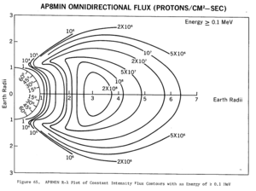

AP8 MIN omnidirectional proton flux ≥ 100 keV

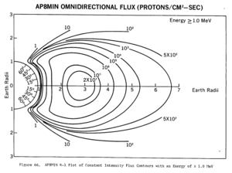

AP8 MIN omnidirectional proton flux ≥ 1 MeV

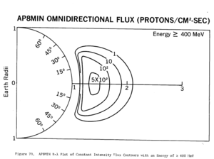

AP8 MIN omnidirectional proton flux ≥ 400 MeV

**Antimatter confinement**

In 2011, a study has confirmed earlier speculation that the Van Allen belt could confine antiparticles. The PAMELA experiment detected orders of magnitude higher levels of antiprotons than are expected from normal particle decays while passing through the SAA. This suggests the Van Allen belts confine a significant flux of antiprotons produced by the interaction of the Earth's upper atmosphere with cosmic rays. The energy of the antiprotons has been measured in the range from 60–750 MeV.

**Implications for space travel**

Spacecraft travelling beyond low Earth orbit leave the protection of earth's geomagnetic field and transit the Van Allen belts. Beyond these, they face additional hazards from cosmic rays and solar flares. A region between the inner and outer Van Allen belts lies at two to four Earth radii and is sometimes referred to as the "safe zone".

Solar cells, integrated circuits, and sensors can be damaged by radiation. Geomagnetic storms occasionally damage electronic components on spacecraft. Miniaturization and digitization of electronics and logic circuits have made satellites more vulnerable to radiation, as the total electric charge in these circuits is now small enough so as to be comparable with the charge of incoming ions. Electronics on satellites must be hardened against radiation to operate reliably. The Hubble Space Telescope, among other satellites, often has its sensors turned off when passing through regions of intense radiation. A satellite shielded by 3 mm of aluminum in an elliptic orbit (200 by 20,000 miles (320 by 32,190 km)) passing the radiation belts will receive about 2,500 rem (25 Sv) per year. Almost all radiation will be received while passing the inner belt.

The Apollo missions marked the first event where humans traveled through the Van Allen belts, which was one of several radiation hazards known by mission planners. The astronauts had low exposure in the Van Allen belts due to the short period of time spent flying through them. Apollo flight trajectories bypassed the inner belts completely to send spacecraft though only the thinner areas of the outer belts. The command module's inner structure was an aluminum "sandwich" consisting of a welded aluminum inner skin, a thermally bonded honeycomb core, and a thin aluminum "face sheet". The steel honeycomb core and outer face sheets were thermally bonded to the inner skin.

Astronauts' overall exposure was actually dominated by solar particles once outside Earth's magnetic field. The total radiation received by the astronauts varied from mission to mission but was measured to be between 0.16 and 1.14 rads (1.6 and 11.4 mGy), much less than the standard of 5 rem (50 mSv) per year set by the United States Atomic Energy Commission for people who work with radioactivity.

**Causes**

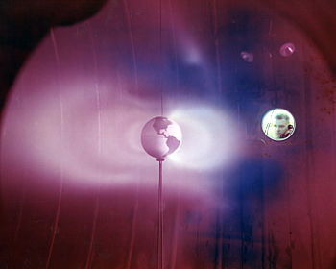

Simulated Van Allen Belts generated by a plasma thruster in tank #5 at the Electric Propulsion Laboratory located at the then-called Lewis Research Center, Cleveland, Ohio

It is generally understood that the inner and outer Van Allen belts result from different processes. The inner belt, consisting mainly of energetic protons, is the product of the decay of so-called "albedo" neutrons which are themselves the result of cosmic ray collisions in the upper atmosphere. The outer belt consists mainly of electrons. They are injected from the geomagnetic tail following geomagnetic storms, and are subsequently energized through wave-particle interactions.

In the inner belt, particles are trapped in the Earth's nonlinear magnetic field, that originate from the sun. Particles gyrate and move along field lines. As particles encounter regions of larger density of magnetic field lines, their "longitudinal" velocity is slowed and can be reversed, reflecting the particle. This causes the particles to bounce back and forth between the Earth's poles. Globally, the motion of these trapped particles is chaotic.

A gap between the inner and outer Van Allen belts, sometimes called safe zone or safe slot, is caused by the Very Low Frequency (VLF) waves which scatter particles in pitch angle which results in the gain of particles to the atmosphere. Solar outbursts can pump particles into the gap but they drain again in a matter of days. The radio waves were originally thought to be generated by turbulence in the radiation belts, but recent work by James L. Green of the Goddard Space Flight Center comparing maps of lightning activity collected by the Microlab 1 spacecraft with data on radio waves in the radiation-belt gap from the IMAGE spacecraft suggests that they are actually generated by lightning within Earth's atmosphere. The radio waves they generate strike the ionosphere at the right angle to pass through it only at high latitudes, where the lower ends of the gap approach the upper atmosphere. These results are still under scientific debate.

**Proposed removal**

**High Voltage Orbiting Long Tether**, or HiVOLT, is a concept proposed by Russian physicist V.V. Danilov and further refined by Robert P. Hoyt and Robert L. Forward for draining and removing the radiation fields of the Van Allen radiation belts that surround the Earth. A proposed configuration consists of a system of five 100 km long conducting tethers deployed from satellites, and charged to a large voltage. This would cause charged particles that encounter the tethers to have their pitch angle changed, thus over time dissolving the inner belts. Hoyt and Forward's company, Tethers Unlimited, performed a preliminary analysis simulation in 2011, and produced a chart depicting a theoretical radiation flux reduction, to less than 1% of current levels within two months for the inner belts that threaten LEO objects.

**See also**

* [Dipole model of the Earth's magnetic field](https://en.wikipedia.org/wiki/Dipole_model_of_the_Earth%27s_magnetic_field)
* [L-shell](https://en.wikipedia.org/wiki/L-shell)
* [List of artificial radiation belts](https://en.wikipedia.org/wiki/List_of_artificial_radiation_belts)
* [List of plasma (physics) articles](https://en.wikipedia.org/wiki/List_of_plasma_(physics)_articles)
* [Space weather](https://en.wikipedia.org/wiki/Space_weather)

This page was last modified on 7 November 2015, at 19:53.